**LINUX Commands document**

Basic Commands:

* man: This command will help to get manual for usages of any command. Suppose, it is command for man ls:

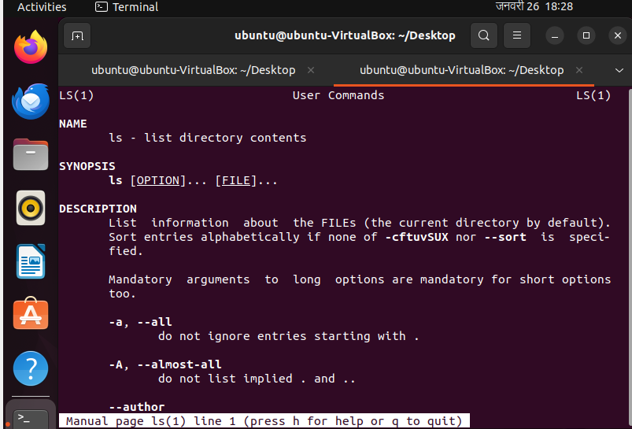

* pwd(present working directory): It will show in which directory we are working.

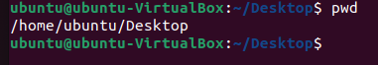

* cd: change directory

current path command to change directory to inside file

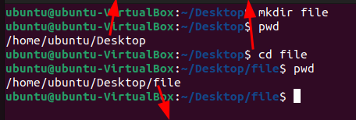

Now current directory is file

* ls: list all files.

list file from desktop 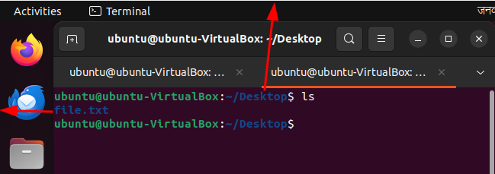

* mkdir: make directory

file1.txt has been created command to make new directory named file1.txt

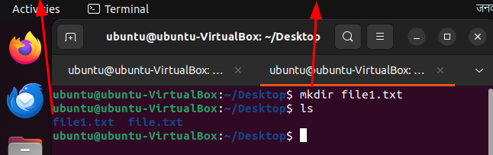

* To make directory recursively

Change directory Command to create directory recursively

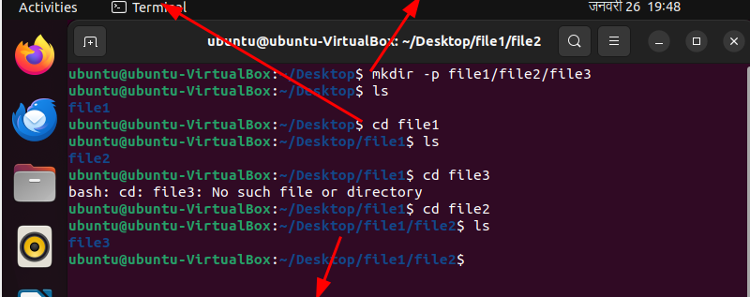

Changing directories

* rmdir: remove directory

present files command to remove files

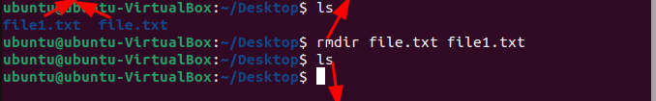

Files has been removed

Note: rmdir is used for empty directory.

* rm –r : remove with recursive

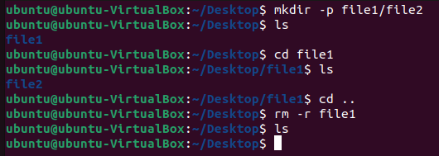

* cd .. :This command will helps to roll back to previous directory.

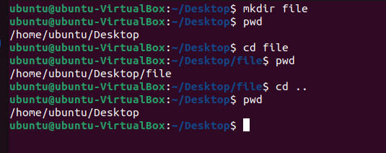

* touch: creating file

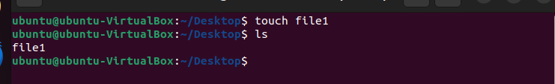

* echo : To write something to file

Create file1 writing welcome on file1

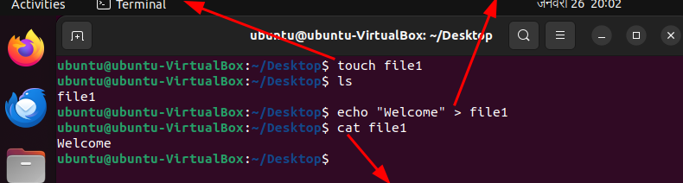

cat command is used to display content of file1

* >> is used for append and > is used for overwrite.

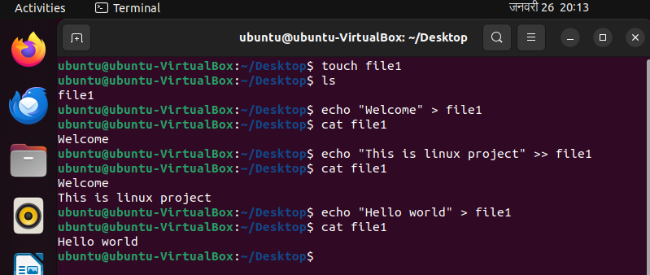

* mv: move command is used for two purpose:

1. to rename the name of file

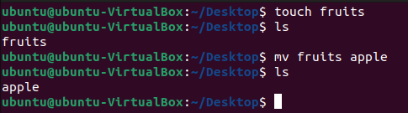

1. to move document to any directory or file

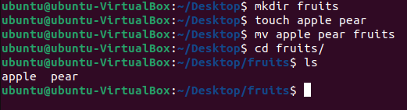

* cp : to copy the content of file

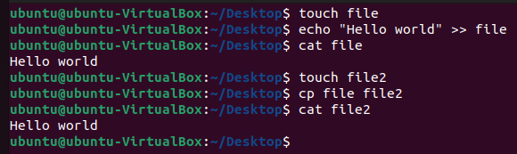

* open: to open any file

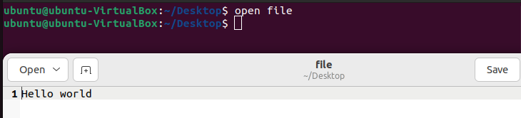

* find: to find any file or folder with certain search pattern

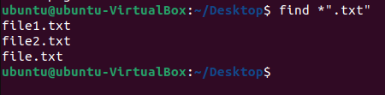

* ping : to check connectivity

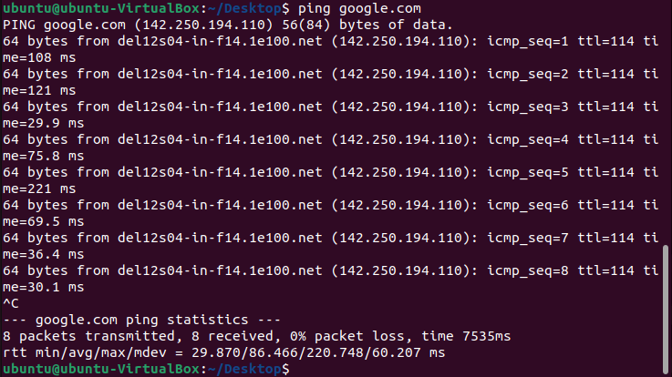

* tail: to print last 10 lines of an file

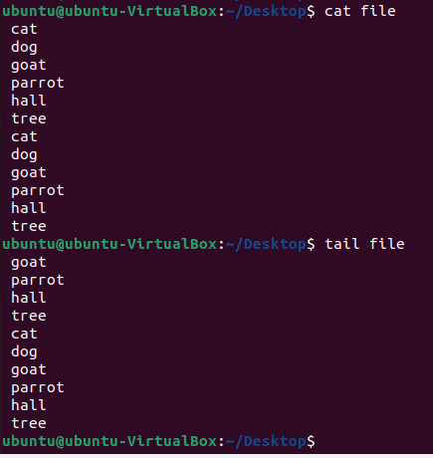

Permission and Ownership:

* ll(long list): to view files name with information about owner and permission

file size date of creation

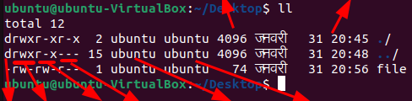

Dire poo pog poou owner group

Ctory

Poo: permission of owner

Pog: permission of group

Poou: permission of other user